SS JAWABAN TES ARKADEMI


3.
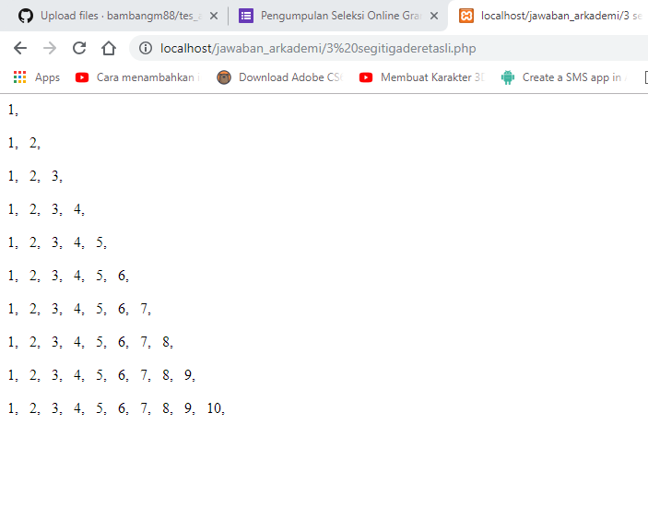
4.
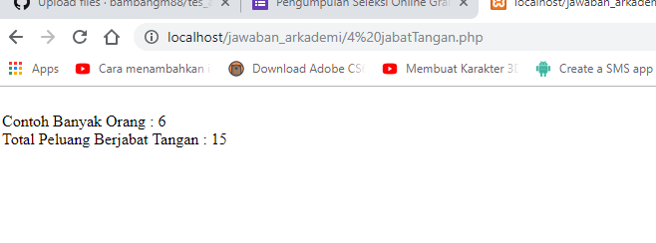

5


6.
SELECT product_categories.category_id,product_categories.name, COUNT(products.category_id) as jumlah from product_categories LEFT JOIN products on product_categories.category_id = products.category_id GROUP BY product_categories.category_id asc
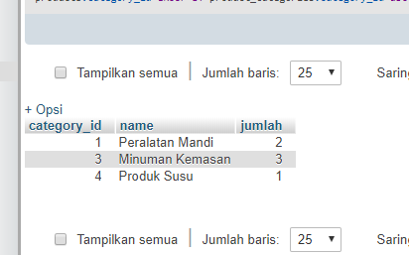

7.
